|  |  |
| --- | --- |
| **Job Description – Northampton International Academy** | |
| **Job title:** | Child and Family Support Worker |
| **Responsible to:** |  |
| **Liaising with:** | SLT, curriculum leaders, Heads of subjects, faculty teachers, parents/carers, trust central team, relevant support staff |
| **Pay range:** | NJC 9-13 39 weeks per year (TT plus one week) |
| **Contract terms:** | Permanent |

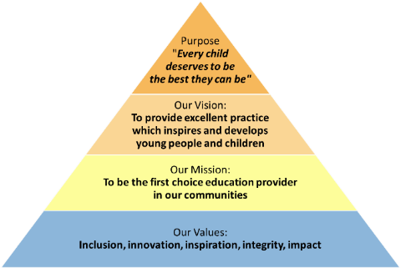

All staff should be committed to the school and East Midlands Academy Trust’s purpose to provide a relentless focus on great leadership and management and outstanding teaching. East Midlands Academy Trust is committed to support the school leaders, teachers and support staff to be the best they can be.

**Role of the Child and Family Support Worker**

This pastoral post has responsibility for:

* Positively and proactively working alongside learning, parents, and families to engage in school life
* Implementing and reviewing the strategy for the child and family provision within the school
* Liaise with pastoral team to identify children who would most benefit from learning interventions or family support work
* Instigating positive mentoring relationships through appropriate and creative interventions
* Help identify and prioritise vulnerable children through information sharing
* Assisting with additional pastoral duties, such as Breakfast Club provision
* Attending Child in Need meetings in the absence of the DSL
* Informally addressing parental concerns

**Additional duties**

* Occasionally liaise with appropriate outside agencies to support identified children and families
* When appropriate, refer to alternative interventions or agencies, such as CAMHS
* Carry out, and record, home visits

**N.B.** The post holder will carry out his/her responsibilities in accordance with the Trust’s equal opportunities policy.

**Health and Safety**

So far as is reasonably practical, the post holder must ensure that safe working practices are adopted by employees, and in premises/work areas for which the post holder is responsible, to maintain a safe working environment for employees and learners.

**Safeguarding**

EMAT is committed to the safeguarding of its young persons and expects all staff, volunteers and adults to work within the parameters of the policies and procedures as agreed by the Board of Trustees to ensure the safety of all young persons within its care.

**Equal Opportunities**

It is the policy of EMAT to provide equal opportunities for all individuals; to prohibit discrimination in employment on any basis protected by applicable law, including but not limited to race, colour, religious creed, marital status, sex, sexual orientation, ancestry, national origin, age, medical condition or disability. EMAT promotes equal employment opportunities in all aspects of employment through positive employment policies and practice.

If any special requirements are needed to attend an interview, please inform the trust.

|  |  |
| --- | --- |
| Compiled by: **HR** | Revision Number: vX |
| Approved by Headteacher: | Revision Date ___/___/___ |
| Approved by HRBP: | Date: ___/___/___ |
| Agreed by Headteacher: | Date: ___/___/___ |
| Agreed and signed by post holder: | Date: ___/___/___ |

**East Midlands Academy Trust is committed to safeguarding and promoting the welfare of children and young people and expects all staff and volunteers to share this commitment.**

**All appointments are subject to safer recruitment requirements.**

**This post is subject to an Enhanced DBS Disclosure**

**Person Specification**

|  |  |  |
| --- | --- | --- |
|  | **Essential** | **Desirable** |
| **Education and Qualifications** | | |
| Designated Safeguarding Lead (or willingness to complete) | **✓** |  |
| 123 Magic, Freedom Programme, or other similar relevant programmes (or willing to complete) |  | **✓** |
| **Experience** | | |
| Behaviour management for identified pupils | **✓** |  |
| Early Help Assessment Framework |  | **✓** |
| Attending Child in Need meetings |  | **✓** |
| Assisting with additional pastoral duties (i.e. Breakfast Club) |  | **✓** |
| **Knowledge and understanding** | | |
| Working alongside a variety of different family units | **✓** |  |
| Referrals to external agencies (i.e. CAMHS, MASH) | **✓** |  |
| Storing information confidentially and sharing with relevant people | **✓** |  |
| **Skills and Attributes** | | |
| Engaging parents in school life | **✓** |  |
| Developing creative interventions |  | **✓** |
| Working as part of a wider team | **✓** |  |
| **Personal Qualities** | | |
| High professional standards | **✓** |  |
| High expectations of learners and staff | **✓** |  |
| Passion for helping children thrive | **✓** |  |
| Willingness to be involved in wider school life | **✓** |  |
| **Further requirements** | | |
|  |  |  |
|  |  |  |
|  |  |  |