Post Description:
Post title: | Level 3 Nursery Nurse
Responsible to: | EYFS Lead/Head of School
Liaising with: | Nursery staff  EYFS Lead/Head of School  School staff  Parents and carers
Pay range: | TA/Support Staff pay scale pro-rata of SCP 2-3
Contract terms: | 37.5 hours over 5 days (8am to 4pm) 39 weeks/year (Term time plus training days)

Job Purpose
Working with the EYFS staff team to deliver high quality childcare and education throughout the nursery

Responsibilities include:

● assist in the daily operation of the nursery
● to be a member of a multi-disciplinary team, communicating and working together to create an environment in which children’s development is fostered and in which good relationships grow
● take responsibility for promoting and safeguarding the welfare of children
● assist in providing a high quality of teaching and offer appropriate stimulation and support to all children including those with special educational needs and those for whom English is an additional language
● assist in planning, creating and implementing nursery activities and events suitable for all children
● be responsible for implementing systems of observation and record keeping so that children’s progress is effectively and regularly assessed; to monitor the effectiveness of assessment procedures.
● ensure records are properly maintained, e.g. daily attendance register, accident and incident records
● develop partnerships with families and liaise closely with parents/carers,
● ensure the nursery is a safe environment for children, that equipment is safe, standards of hygiene are high, safety procedures are implemented at all times
● ensure that all legal and statutory requirements are implemented; to provide reports as required.
● adhere to the schools’ policies and procedures
● promote positive behaviour
● assist in the preparation and cleaning up of activities
● advise the Early Years Lead of any concerns, accidents/incidents
● attend in-service training and meetings as required
● carry out any other tasks which may reasonably be required as part of this post
Compiled by: | Revision Number
Approved by: | Revision Date ___/___/___

Attribute | Essential | Desirable
Qualifications and training | - L3 Early Years Educator / Early Childhood Studies (full qualification with assessment element). | - Current Paediatric First Aid Certificate
Experience | - Experience of working in and Early Years setting  - Sound understanding of child development and of children’s learning needs  - Sound knowledge of the EYFS and Characteristics of Effective Learning  - Ability to plan and implement a stimulating Early Years curriculum, outdoors and indoors skills.  - Experience of assessment within early years. | Experience of working with children with special educational needs.
Knowledge and skills | - Ability to take the initiative  - Ability to work constructively within a small team  - Good communication skills  - Good IT skills to support learning  - Ability to engage parents and support their involvement in children’s learning  - Commitment to Equal Opportunities and understanding of religious and cultural diversity  - Ability to monitor children’s progress and write regular reports | Monitoring behaviour and well being.
Personal qualities | - A deep professional interest and joyful enthusiasm for working with children  - A love of nature and working with children outdoors in all weathers  - Plenty of enthusiasm and energy  - Honesty, reliability and a sense of humour

Additional duties

Whilst every effort has been made to explain the main duties and responsibilities, please note that this is illustrative of the general nature and level of responsibility of the work to be undertaken, commensurate with the grade. It is not a comprehensive list of all tasks that the post holder will carry out. Employees will be expected to comply with any reasonable request from a manager to undertake work of a similar level that is not specified in this job description.

N.B. The post holder will carry out his/her responsibilities in accordance with the Trust’s equal opportunities policy.

This job description is provided to assist the post holder to know what his/her duties are. It may be amended from time to time without change to the level of responsibility appropriate to the grade of the post.

About East Midlands Academy Trust

All staff should be committed to the school and East Midlands Academy Trust’s purpose, values and objectives.
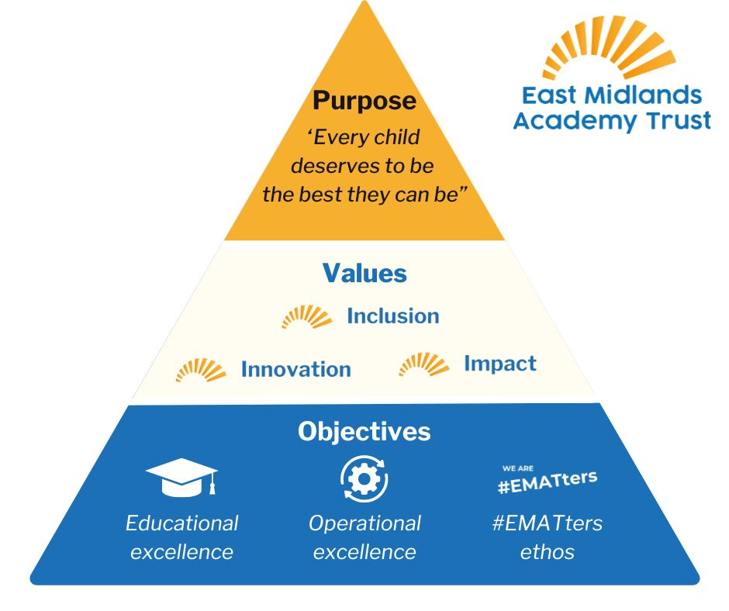

Health and Safety

So far as is reasonably practical, the post holder must ensure that safe working practices are adopted by employees, and in premises/work areas for which the post holder is responsible, to maintain a safe working environment for employees and learners.

Safeguarding

EMAT is committed to the safeguarding of its young persons and expects all staff, volunteers and adults to work within the parameters of the policies and procedures as agreed by the Board of Trustees to ensure the safety of all young persons within its care.

Equal Opportunities

It is the policy of EMAT to provide equal opportunities for all individuals; to prohibit discrimination in employment on any basis protected by applicable law, including but not limited to race, religious creed, marital status, sex, sexual orientation, ancestry, national origin, age, medical condition or disability. EMAT promotes equal employment opportunities in all aspects of employment through positive employment policies and practice.

If any special requirements are needed to attend an interview, please inform the trust.

